**Eisha Fatima**

**41769**

**BSCS – 6TH**

**Computer Network – Lab 4**

**Task 1:**

Connect 4 PCs with the HUB in cisco packet tracer and send data from PC 1 to PC 2 and check the working of HUB through simulation mode.

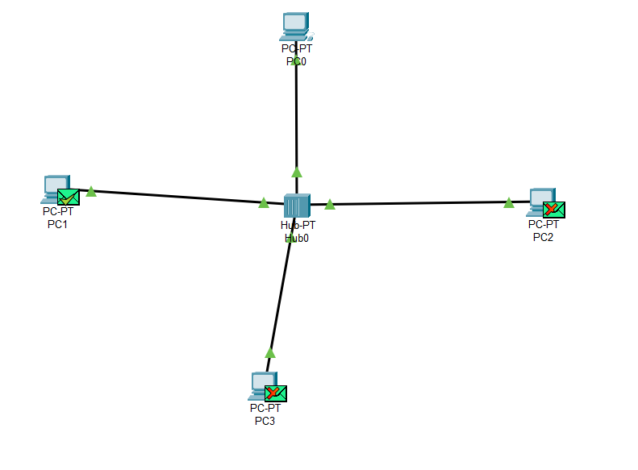

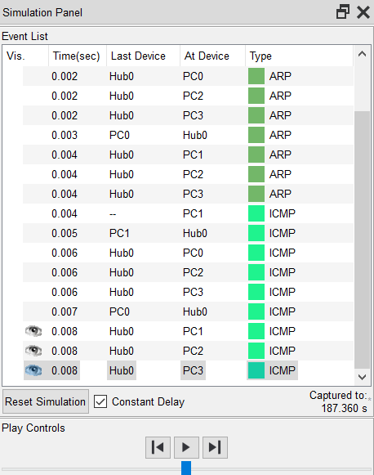

**Task 2:**

Connect 4 PCs with the SWITCH in cisco packet tracer and send data from PC 1 to PC 2 and check the working of SWITCH through simulation mode.

